STOCK MARKET TRACKER OUTPUTS
- Main page showing top Indian Indices and a message showing Indian market active time and IST clock time.
Also showing total order, buy order etc.
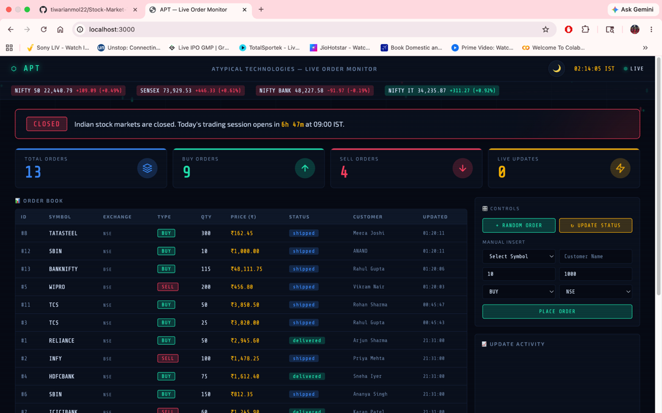

- Main page in white mode, shows Order book
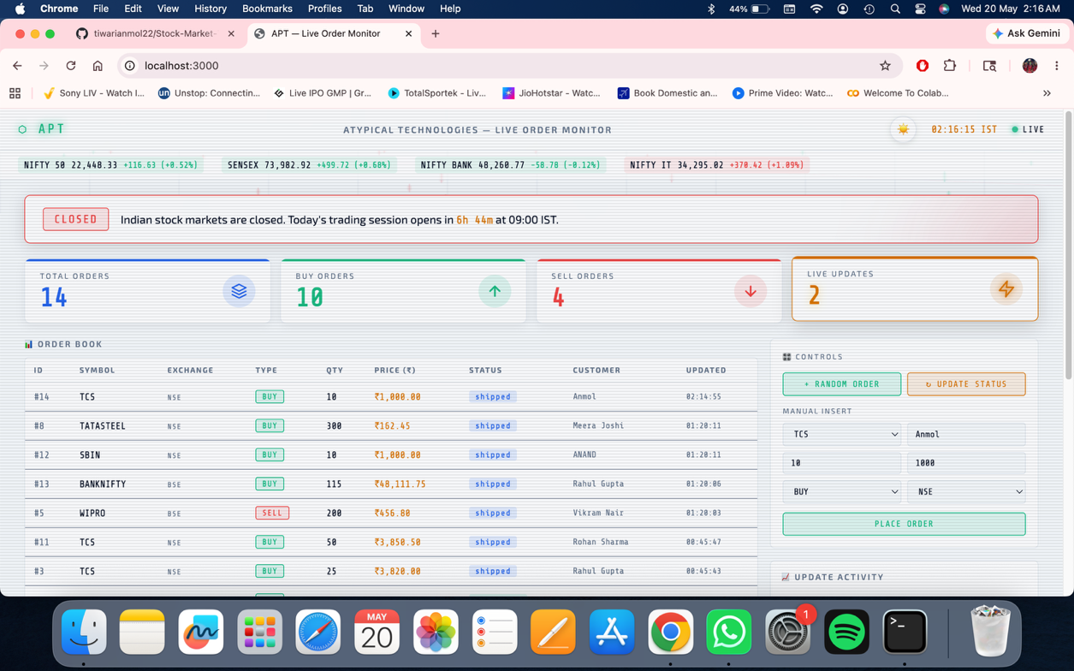
- Control Bar with option to buy stocks, top stocks listed in dropdown menu
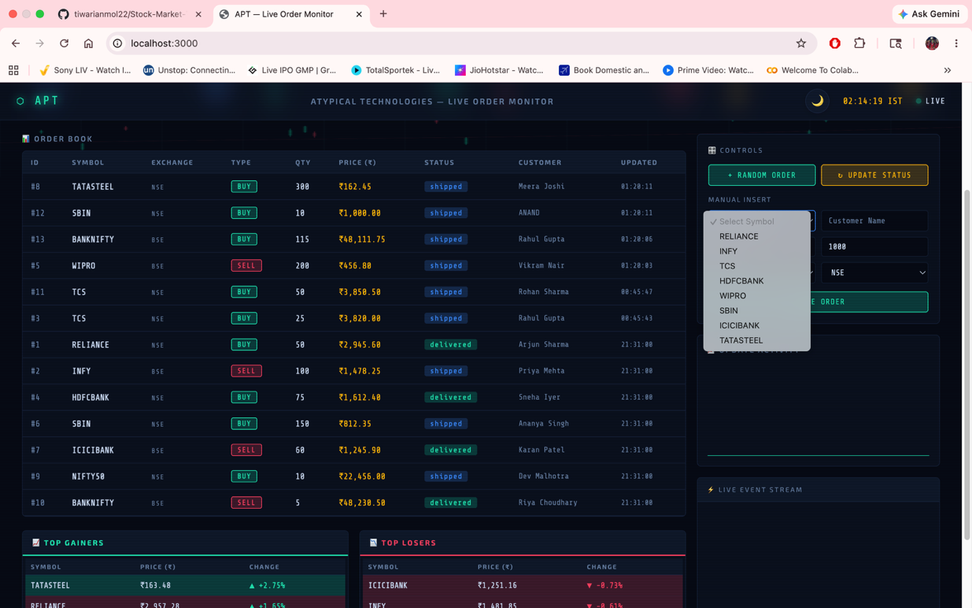

- Buy order placed for TCS stock, live activity graph and live activity notification update
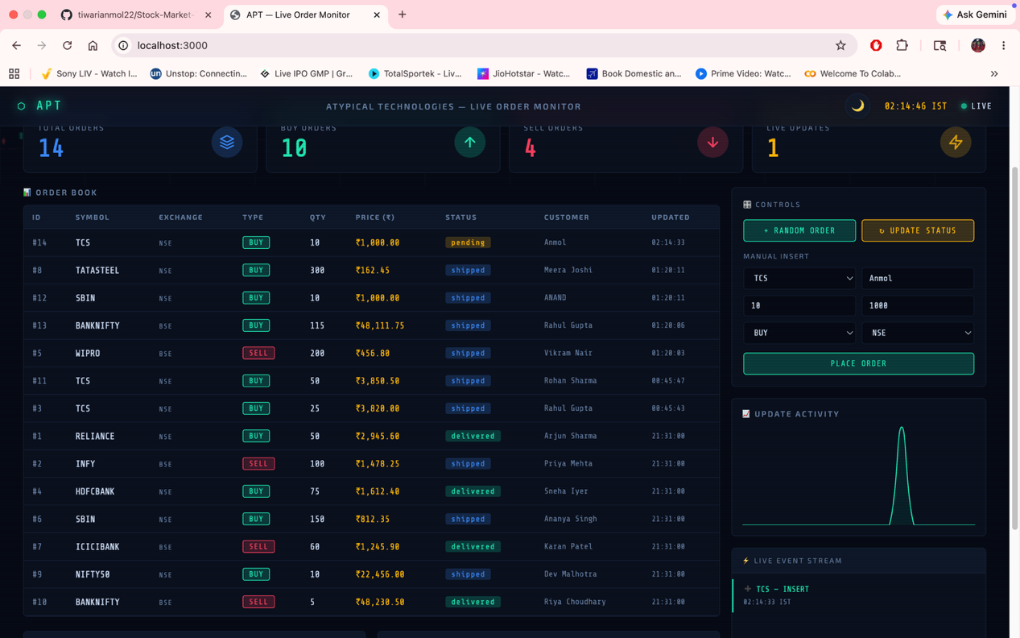

- Order updated and shipped (not delivered as market is closed) , Also top gainers and losers of the day shown for user information
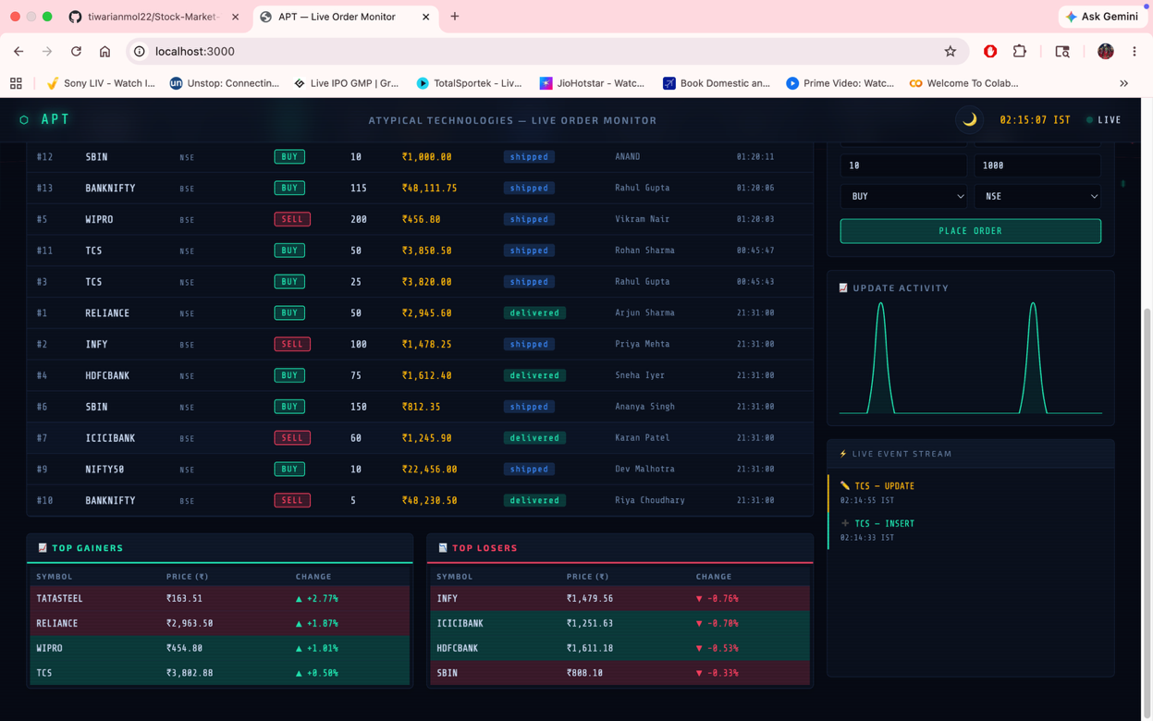

- Backend MySQL Updated tables (frontend-backend connectivity)
